UNIT-III
MICROSOFT EXCEL

3.1 EXCEL BASICS
3.1.1 INTRODUCTION
- Ms-excel are one of the powerful packages that store the data. In that spreadsheet is nothing but worksheet, that is essentially comprises of a grid of rows and columns. Intersection of a row and a column is called a cell.
- Typically rows are numbered numerically 1, 2, 3…. And so on and columns are labeled alphabetically A, B, C… and so on.
- Each workbook provides 3 worksheets with facility to increase the number of sheets.
- Each sheet provides 256 columns and 65536 rows to work with.

- Starting Excel
- Switch on your computer and click on the Start button at the bottom left of the screen.
- Move the mouse pointer to Programs, then across to Microsoft Excel, then click on Excel as shown in this screen.
- When you open Excel a screen similar to this will appear
- Navigating:
To move around the spreadsheets either uses the keyboard keys left, right, up & down.
- Selecting cells:
Before entering, editing or formatting cells, they need to be selected. You can select a single cell or a group of continuous cells or even a discontinuous group of cells. This selection is called a range.
- Selecting cells with mouse:
- To select a single cell, simply point and click on it to make it active.
- Click on a row no to select entire row.
- Click on the empty button at the intersection of the column and row numbers to select the entire worksheet.
- Entering & editing text:
To enter any text, simply activate any cell by clicking on it. And start typing. Press enter to conclude entry. As you start typing the text would appear in the active cell and in the formula bar. If you make a mistake while typing and before pressing enter simply press backspace key to erase the present contents.
- Entering numbers:
Numbers are basic raw material for spreadsheets. You can type numbers either by using the number keys on top of letter keys or by using extended numeric pads on the keyboard.
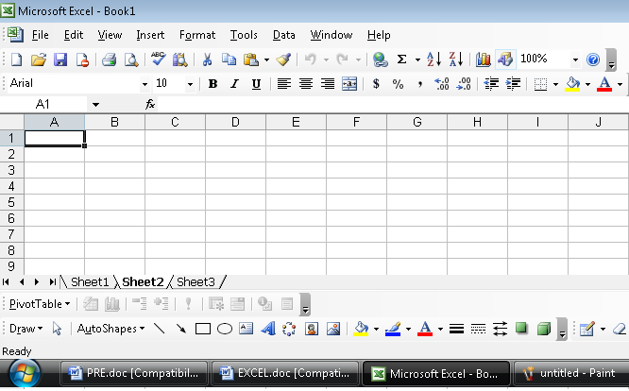

Mathematical symbols are like,
- Division / 5.Multiplication *
- Addition + 6.Subtraction _
- Percentage % 7.Decimal .
- Exponents ^ 8.Parentheses ( )
Comparison operators are like,
- Equal to =
- Greater that >
- Less than <
- Greater than or equal to >=
- Less than or equal to <=
- Not equal to <>
- You can either build formulas using absolute numbers (like = 4+3) or use relative cell address (like =A1+B1). As a general rule of thumb, you must always use relative cell referencing because in case the values change in future the formulas based upon these values would automatically show the updated results.
- For instance you would either type =A1- B1 in the cell C1 and press enter, or place the mouse pointer in cell C1 and type = sign and click the cell A1, type _, point and click at cell B1 And press enter.
- Entering dates:
In excel dates are stored as numbers that is number of days that have elapsed since 1st January 1990. Suppose you wish to find out how many days have elapsed between two dates, you can give a formula to subtract the two dates just like any other number.
- Alignment:
Any text that you type is always left aligned within the cell. Any number that you type is always right aligned within the cells. You want to place the text in center means, select the center alignment icon in formatting tool bar.

3.2 Menus, toolbars and icons
- Menus:
- Users used to type long string of code words called commands, for making the computer do anything.
- The user had to remember these coded commands for each step that he wished to execute.
- All windows based software comes with a set of graphical buttons with small picture on them. These buttons are called icons save you the bother of having to remember long commands.
- Instead of having to type commands users could choose the command from a list called a menu.
- Group of icons, which perform related, tasks are placed together in a ribbon, called a tool bar. There are many tool bars. Standard toolbar, formatting toolbar, drawing tool bar, tables and borders toolbar etc..
- In ms-excel spreadsheet the top line is called menu bar. It can contain Varity of menus.
- The menu bar can contain the menus like file, edit, view, insert, format, tool, help etc…. Let us the see the menu one by one.

- FILE MENU
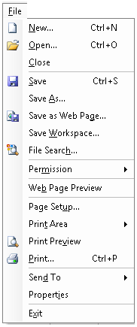
New: creates a new blank file based on default values contained in a file called normal.xls.
Open: opens or finds an existing document.
Close: closes the active file without exiting the application. If the file contains any unsaved changes, you will be prompted to save the file before closing.
Save: saves the active file with its current file name, location, and file format.
Save as: saves the active file with a different file name, location or file format.
Save as web page: Saves the file in web page format required for creating documents for the internet (World Wide Web).
Web page preview: Allows you to preview the current file as web page in your browser so that you can see how it will look before publishing it.
Page setup: sets margins, paper source, paper size, page orientation, and other layout options for the active file.
Print preview: shows a preview of how exactly a file will look when you print it.
Print: Prints the active file or selected items, to the selected printer or fax.
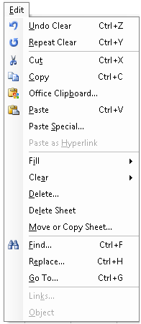
Send to: Sends the document to a mail recipient as an e-mail.
Properties: Displays the property sheet for the active file.
Exit: close the Ms Excel file after prompting you to save any unsaved files.

- EDIT MENU
Undo last command(s): Reverses the last command i.e. undoes the effect of the last command you executed.
Replace last command(s): Reverses the Undo command i.e. restores the last command.
Cut: Removes the selection from the active document and places it on clipboard-a special place in computer’s memory from where it can be retrieved again.
Copy: Copies the selection to the clipboard.
Paste: Inserts the contents of the clipboard at the insertion point, and replaces any current selection (block).
Paste special: Pastes, links, or embeds the clipboard content in the current file in the format you specify.
Paste as Hyperlink: Inserts the content of the clipboard as a Hyperlink at the insertion point, replacing any selection.
Fill: Fills the specified range with a series of numbers, dates, or other items.
Clear: Deletes the selected object or text without putting it on the clipboard.
Delete: Deletes the selected cells or the cell that contains the insertion point.
Delete Sheet: Delete the selected sheets from the workbook.
Move or Copy Sheet: Moves or copies the selected worksheets to another workbook or to a different location within the same workbook.
Find: Searches for specified text, formatting, symbols, comments, footnotes, endnotes in the active document.
Replace: Searchers for and replaces specified text, formatting, footnotes, endnotes or comment mark in the active document.
Go To: Moves the insertion pointer to the item where you want to go.
Links: Displays or changes information for each link in the current file, including the name and location of the source file, the item, the type and whether the link is updated automatically or manually.
Object: Activates the application in which the selected object was created so you can edit.

- VIEW MENU
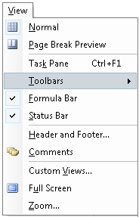
Normal: Switches to normal view, which is the default, document view for most word processing tasks.
Page break preview: Switches to page layout or break preview, which is an editing view that displays your document as will print.
Task pane: Displays the task pane, an area where we can create new files, search for information, view the contents of the clipboard, & perform other tasks.
Toolbars: Toolbars allow you to organize the commands in excel, the way you want to so that you can find and use them quickly. Toolbars can contain buttons, menus, or combinations of both.
Formula bar: Displays or hides the formula bar
Status bar: Displays or hides the status bar
Header & footer: Adds or changes the text that appears at the top and bottom of every worksheet.
Comments: Displays all comments made by all reviewers in the comment pane.
Customs Views: Creates different views of a worksheet.
Full screen: Hides most screen elements so that you can view more of your document.
Zoom: Enter a magnification between 10 & 200 percent to reduce or enlarge the display of the active document.
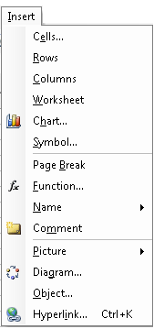
- INSERT MENU
Cells: Inserts the number of cell you select.
Rows: Inserts the number of rows you select
Columns: Inserts the number of columns you select
Worksheet: Inserts a new worksheet to the left of the selected sheet.
Chart: Starts the wizard, which guides you through the steps for creating an embedded chart on a worksheet or modifying an existing chart.
Page break: Inserts a page break above a selected cell. This command changes to remove page break if you have a cell selected that is adjacent to a manually inserted page break.
Function: Displays a list of functions and their formats and allows you to set values for arguments.
Name: Defines, creates, pastes and applies names
Comment: Inserts pictures from clip art and other libraries.
Picture: Insert picture from the clip art and other libraries.
Object: Inserts an object such as a drawing, word art text effect etc.

- FORMAT MENU:
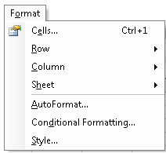
Cells: Applies formats to the selected cells. The command might not available if the sheet is protected.
Rows: Formats rows increases / decreases heights, autos fits selection and hides / unhide rows.
Column: Formats columns increases / decreases heights, autos fits selection and hides / unhide columns.
Sheet: Formats worksheets –renames, hides or unhide sheets
Auto format: Applies a built in combination of formats called an auto format, to a cell range or a table. If a single cell is selected excel automatically selects the range surrounded by blank cells and applies the auto format to that range.
Conditional formatting: Applies formats to the selected cells that meet specific criteria based on values or formulas you specify.
Style: Defines or applies to the selection a combination of formats called a style.

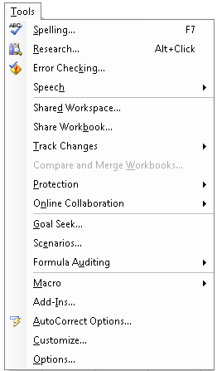
- TOOLS MENU
Spelling & grammar: Checks the active document for possible spelling, grammar and writing style errors, and displays suggestions for correcting them.
Research: It provides access to a number of free-based reference tools, including references books, research sites, business & financial sites and services.
Error checking: check the active worksheet for errors.
Speech: Sets up and customizes speech recognition for dictating text, as well as selecting menu, toolbar, and dialog box items.
Shared work space: A shared work space is an area of Microsoft Windows SharePoint Services sites that we can open in a web browser or in the Shared workspace task pane in a Microsoft office program.
Share workbook: Switches to shared workbook mode which allows you and another users on your network to edit and save changes to the same workbook.
Track Changes: Marks changes in the current document and keeps track of each change by reviewer name.
Compare & Merge workbooks: Merges the tracked changes from the active document into the
specified document, which Word opens if it is not open already.
Protection: Prevents changes to all or part of an online form or document except as specified. You can also assign a password so that other users can annotate a document, mark revisions, or fill in parts of an online form?)
Online Collaborations. Starts an impromptu online by sending an invitation to participants who must be running Microsoft NetMeeting on their computers'. It also schedules an online meeting by using names from the address book of your e-mail program, and displays the Discussions toolbar, where you can insert a new discussion.
Goal seeks: Adjusts the value in a specified cell until a formula that is dependent on that cell reaches a target value.
Scenarios: Creates & saves scenarios, which are sets of data you can use to view the results of what- if analyzes.
Formula Auditing: Finds cells that have a relationship to a formula, displays formulas affecting by changes in a cell, and tracks down the source of errors values.
Macro Opens the Macros dialog box, where you can run, edit or delete a macro Use Record New Macro to record a series of actions as a macro, or click Visual Basic Editor to write a macro. Use security to set high, medium or low security level for-files that might contain macro viruses.
Add-Ins Attaches a different template to the active document, loads add-in programs, or updates a document's style. Also loads additional templates.
AutoCorrect Options: Sets the options used to correct text automatically as you type, or to store and reuse text and other items you use frequently.
Customize Customizes toolbar buttons, menu commands, and shortcut key assignments.
Options Modifies settings for Microsoft Office programs such as screen appearance, printing, editing, spelling and other options.

- DATA MENU
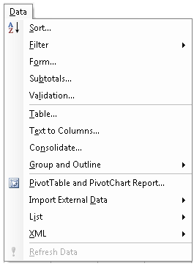
Sort: Arranges the information in selected rows or lists alphabetical in numerically or by date.
Filter: Displays only those rows that match the value in the active cell and AutoFilter arrows to the right of each column label.
Form: Displays a data form in a dialog box. You can use the data form to see, change, add, delete and find records in a list or database.
Subtotals: Calculates subtotals and grand totals values for the labeled columns you select . MS Excel automatically inserts and labels the total rows and outlines in the lists.
Validation: Defines what data is valid for individual cells or cell ranges, restrict the data entry for to a particular type such as whole numbers, decimal numbers or text and set limits on the valid entries.
Table: Creates a data table based on input values and formulas you define. Data tables can be used to show the result of changing values in your formulas.
Text To Columns: Separate text in one cell on a worksheet onto columns by using the Convert Text to Columns Wizard.
Consolidate: Summarizes the data from one or more source area and displays it in a table.
Group & Outline: Creates & clean groups, subgroups & outlines.
Pivot table & pivot chart report: Starts the PivotTable wizard, which guides you through creating or modifying a PivotTable.
Get External Data: Creates & runs Web or data base Queries.
Refresh data: Updates the data in a PivotTable if the Source data has changes.

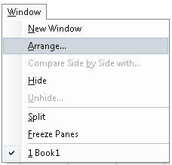
WINDOWS:

New window: opens the new window with the same contents as the active window so you can view different parts of a file at the same time.
Arrange all: displays all open files in separate windows on the screen. The arrange command makes it easier to cut, copy and paste between files.
Hide: hides the active workbook window. A hidden window remains open.
Unhide: Displays hidden workbook window.
Split: Splits the active window into panes. The user can specify the size of two windows. In case the current window is already split this option would change to remove split, and can be used to remove the split.
Freeze Panes: freezes the top pane, left pane or both in the active worksheet. Use the freeze Panes button to keep columns & rows title in view while you’re scrolling a worksheet. Freezing titles in a worksheet does not affect printing.

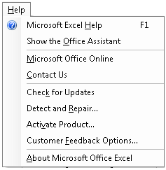
- HELP:
Microsoft Excels help: to launch the Ms office assistant, which provides help and tips to you to execute many tasks.
Show the office Assistant: Displays or removes the office assistant from view.
Microsoft Office Online: It provides a link to Microsoft’s home site containing , free stuff, feedback, answers to frequently asked questions, technical help etc.
Detect & repair: automatically finds and fixes errors in these programs.
About Microsoft excel: show you the Excel’s version details and copyright message along with detailed information about your computer system.

3.3 TOOL BARS & THEIR ICONS
- In MS-Excel, there are physical tools are replaced by command. We have seen that commands are executed by clicking on their specific icons.
- Group of icons that perform related tasks, are place together in a ribbon is called Toolbar.
- There are many toolbars are available in MS Excel such as standard toolbar, formatting toolbar, drawing toolbar ect.

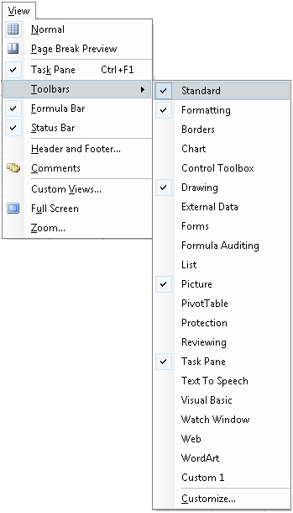
- STANDARD TOOLBAR
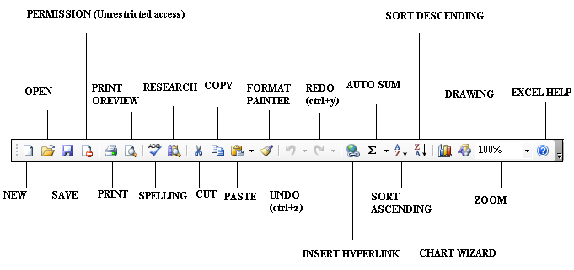
New: Creates a new document based ob normal template.
Alternative: File →New
Shortcut → Ctrl + N.
Open: Opens an existing document or template.
Alternative: File → Open.
Shortcut → Ctrl + O.
Save: Saves the active document or template
Alternative: File → Save.
Shortcut → Ctrl + S.
Print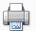: Prints the active document using current defaults.
Alternative: File → Print.
Shortcut → Ctrl + p.
Print Preview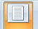: Displays full page as they are printed.
Alternative: File → Print Preview.
Shortcut → Ctrl + F2.
Spelling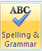: Checks the spelling in the active document .
Alternative: Tools → Spelling and grammar.
Shortcut → F7.

Format Painter: Copies the formatting of the selection to a specified location.
Shortcut → Ctrl + Shift + c.
Print Preview: Displays full page as they are printed.
Alternative: File → Print Preview.
Shortcut → Ctrl + F2.
Cut: Cuts the selection and puts in on the clipboard.
alternative: Edit → Cut.
Shortcut → Ctrl + X.
Copy: Copies the selection and puts it on the clipboard.
Alternative: Edit → Copy.
Shortcut → Ctrl + C.
Paste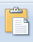: Inserts the clipboard contents at the insertion point.
Alternative: Edit → Paste.
Shortcut → Ctrl + V.
Format Painter: Copies the formatting of the selection to a specified location.
Shortcut → Ctrl + Shift + c.
Undo: Reverses certain commands.
Alternative: Edit → Undo.
Shortcut → Ctrl + Z.
Redo: Reverses the action of the undo command.
Alternative: Edit → Repeat.
Shortcut → Ctrl + Y.
Insert Hyperlink: Displays the destination object, document or page.
Alternative: Edit → Repeat.
Shortcut → Ctrl + K.
Auto Sum: Adds numbers automatically with the SUM function. Excel suggests the range of cells to be added. If the suggested range is incorrect, drag through the range you want, and then press ENTER.
Sort Ascending: Sorts the selected items in order from the beginning of the alphabet, the lowest number, or the earliest date using the column that contains the insertion point If you previously set other sorting options, those options are still in effect.
Alternative: Table->Sort->Ascending
Chart Wizard: Starts the Chart Wizard, which guides you through the steps for creating an embedded chart on a worksheet or modifying an existing chart.
Sort Descending: Sorts the selected item in the order from the end of the alphabet, the highest number, or the highest date, using the column that contains the insertion point. If you previously set order sorting options, those options are still in effect.
Alternative: Table->Sort->Descending
Drawing: Shows or hides the Drawing Toolbar.
Alternative: View->Toolbar->Drawing
Microsoft Excel Help: Provides help topics and tips to accomplish your task.
Alternative: Help->Microsoft Word Help
Shortcut->F1
Zoom Control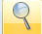: Scales the editing view (Zoom).
Alternative: View → Zoom.
Shortcut → Ctrl + S.

- FORMATTING TOOL BAR
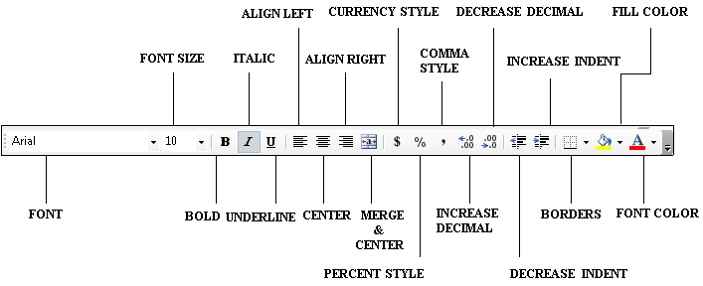

Font style: Applies a style or records a style. Normally here we have four styles that is Bold, Italic, Regular, Bold Italic.
Font size: Changes the format size. Short cut key is ctrl+shift+P
Bold: Makes the selection bold. The short cut key is ctrl+B.
Italic: Makes the selection italics. Short cut key is ctrl+I
Underline: Formats the selection with continuous underline.
Align left: Aligns the paragraph at left indent.
Center: Centers the paragraph.
Align right: Aligns the paragraph at right indent. The short cut key is ctrl+R.
Merge & center: combines 2 or more selected adjacent cells to create a single cell.
Currency: Applies on the international currency style to the selected cells.
Percent Style: applies the personal style to the selected cells.
Comma style: Applies the comma style to the selected cells.
Increase Decimal: Increase the number of digits displayed after the decimal point in the selected cells.
Decrease Decimal: Decrease the number of digits displayed after the decimal point in the selected cells.
Decrease indent: Decrease or promotes the selection one level.
Increase indent: Increases indent or denote the selection one level.
Borders: Shows or hides the border toolbar.
Fill color: Adds, modifies, or removes the fill color or fill effect from the selected object. Fill effects include gradient, texture, pattern or picture fills.
Font color: Selects & applies font color.

- DRAWING TOOL BAR:
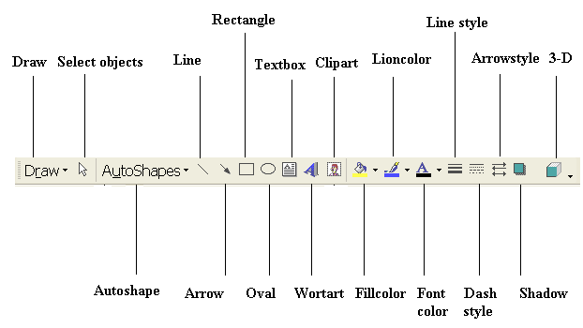
Draw: Activates the draw menu.
Selected objects: Changes the pointer to a selection arrow so you can select objects in the active window. To select a single object, click the object with the arrow.
Auto shapes: Activates the auto shapes menu.
Arrow: Inserts a line with an aero head where you click or drag in the active window. To constrain the line to draw at the 15 degree angles from its starting point.
Oval: Draws an oval where you click or drag in the active window. To draw a circle, press SHIFT and drag.
Word art: Creates text effects by inserting a Microsoft office drawing objects.
Line color: Adds, modifies, or removes the line color from the selected objects.
Insert clip art: Inserts existing picture into file at the desired position from the picture gallery.
Fill color: Adds, modifies, or removes the fill color or fill effect from the selected object
Shadow: Click the shadow style you want for the selected object.

3.4 CREATING A CHART
- Highlight the table, which you want to create a chart.
- Click on the chart wizard icon to start the chart wizard.
- One dialogue box will be opened.
- Select the desired chart type.
- Suppose you select the pie chart, select the 3d chart sub type.
- Click on ‘next’ tab to continue.
- You will get another dialogue box.
- The range of cells, which you have highlighted earlier, would be selected here automatically.
- This signifies that your data series in columns and not rows.
- Click ‘next’ to continue.
- You will get the third dialogue box.
- Type the graphic title 0after choosing title folio.
- Choose legend folio.
- Now another dialogue box will be opened.
- Click here once to specify the data legends to appear on any side of graph you desire.
- Choose data labels folio.
- Choose ‘show percent’ option to display the percentage contribution.
- Click next to continue.
- You will get the last dialogue box.
- Choose combined to place the graph as an object in this sheet.
- Click on the ‘finish’ tab to see the graph.
- Now after getting the graph placed as an object in this sheet, first select the whole graph by clicking on it.

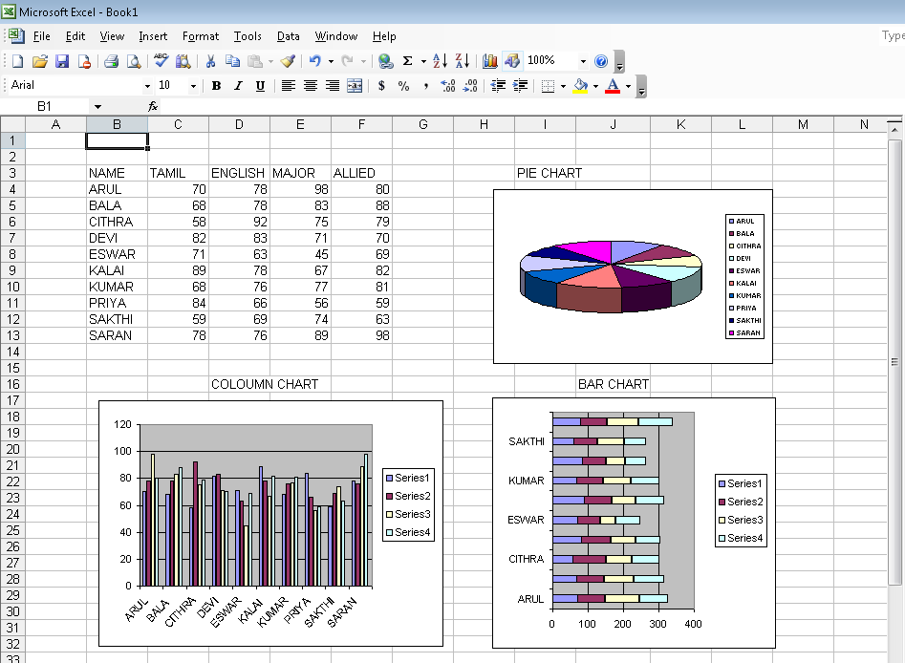

3.5 DATABASE
3.5.1 DATA FORM
Displays a data form in a dialog box. We can use the data form to see, change, add,
delete & find records in a list or database.
1. New: Click the new button to clear the field in the Data Form dialog box & enter data for a new record. Press ENTER to add the record to the end of the list, click close to add the new record & close the data form.
2. Delete: Permanently deletes the displayed record in the data form & in the list.
3. Restore: Click restore before pressing ENTER or scrolling to another record to undo changes we made in the data form.
4. Find previous: Displays the previous record in a record.
5. Find next: Displays the next in a list.
6. Criteria: Finds records based on the criteria we specify. When we click Criteria, the record Number at the Upper right of the form changes to criteria.
7. Close: Close the data form. We must save our workbook to save any records added to our list with the data form.

3.5.2 DATA SORT
Once having prepared the basic spreadsheet let us now learn a few new commands. As you would notice, in the previous record, the names and their details have not been entered in alphabetical order. In order to arrange it in to the alphabetical order, we seek the help of the sort option. It has two models:
- Ascending
- Descending
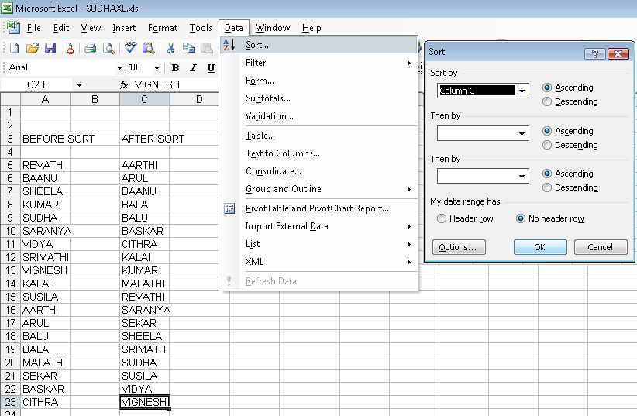

Steps for to Sort the Data
- Highlight the range starting from cell for ex: D6and ending at D24.
- Choose sort command from data menu.
- Click the product name in heading to see the record in alphabetic order.
- It will open one check box.
- It will ask you sorting order depend upon what heading.
- You already selected the product name
- So that place automatically comes with product name.
- You want to select in that place itself whether ascending or descending.
- You wish to apply the sort within the sort choose then by option in the same dialogue box, then Click ok.
- If you want to reverse on descending order choose the descending option.
- While highlighting we had also include the column header row, therefore click here to choose the my list has header row radio button.
- Now your record is in alphabetical order.

3.5.3 DATA FILTER
- Excel spreadsheets can hold as much data as need them to, but we may not want to work with all of the data in a worksheet at the same time. We can limit the data shown on a worksheet by creating a “filter”, which is a rule that selects rows to be shown in a worksheet.
- To create a filter, we click the cell in the group we want to filter & use the Data Menu to turn on Autofilter.
- When we turn on filtering, excel the cell in the active cell’s column as a range. To ensure that the filtering works properly, we should always add a lable to the column we want to filter.

3.6 FORMULAS & FUNCTIONS
- Functions are powerful tools, which help you perform complex computations easily and quickly.
- Functions are like predefined formulas in which the user has to simply provide the values based upon which the calculations are done.
- Typically a function consists of two parts. First one is function name and arguments. Arguments may in some cases be mandatory and in some cases optional.
- The function does the computation on the values provided and shows you the desired results e.g. simple function =SUM ( ) automatically adds up all the values provided in either a range or as individual values.
- Some function can even check things and take action based upon what they find. For instance by using =IF( ) function you can check whether the current value in a particular cell is greater or smaller than 100 and based upon the answer it gets, you can ask the function to multiply or divide this value by a different amount.
- Some function can convert numbers or text to another measure of format, for example the function LOWER ( ) converts the text entry in another cell in to small case.
3.6.1 FORMULAS
- Entering a formulae
- Click File and then click New.
- Enter the data in the new worksheet as shown below

- Cell B6 should contain formula. Move the cell pointer to cell B6.
- Type =B3+B5(formulae and functions should always begin with = sign)
- Cell B6 will now contain the value 350
- Look at cell B6; you will see the result of the formula in the cell B6 rather than formula.
- Now repeat the appropriate formula for cell C6, D6.
- Save your worksheet as cash3.xls.
- Editing Formulae
- Move the cursor to the formula bar with the mouse, clicking once.
- Make the desired changes.
- When you have finished editing the formulae, press the Enter key for the changes to take effect.
(OR)
- Edit the contents by pressing F2 key on the keyboard
- Displaying and Printing formulae
- Click Tools menu and then click Options.
- Click View tab.
- In Window options check Formulas check box. The below screen appears.

- Click OK button.
- To print the worksheet with formulae displayed, click File menu and click on Print Preview.
- If the layout is satisfactory, click on the Print button.

3.6.2 FUNCTIONS
- Round( )
- Sort( )
- Average ( )
- Max ( )
- Min ( )
- Count ( )
- Sum ( )
- If ( )
- Sumif( )
- Abs( )
- Roman( )
- Upper( )
- Lower( )
- Cell( )
- Today( )
- Now( )

ROUND ( )
=Round(range,number_digits)

- The round ( ) function rounds of a number to the specified number of decimal places. In our present example we have a number 3.234 which we want to round off to only two decimals. Let us see how this can be done.
- Place the cursor where you want the function result to appear and choose function from the insert menu.
- Choose math’s & trig from the function category and round from the function name.
- Click once the OK button.
- Either type the cell address or point to the cell, which contains the number to be rounded.
- Specify the number of decimal places to which you want the number to be rounded off.
- Click once the Ok button.

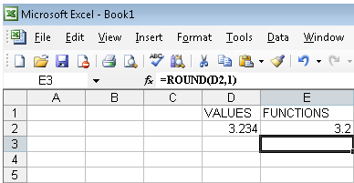

SQRT( )
=Sqrt(range)

- The sqrt function calculates the square root of any specified number. In our present example we have a number 9 for which we want to find out the square root. Let us see how this can be done.
- Place the cursor where you want the function result to appear and choose function from the insert menu.
- Choose math & trig from the function category and sort from the function name. Click once the OK button.
- Either type the cell address or point to the cell, which contains the number for which square root, has to be calculated.
- Click once the OK button.

AVERAGE ( )
=Average(numX:numY)

- The average () function calculates the average of a series of specified numbers. In our present example we have 3 numbers, 3.234,9,81 for which we want to calculate the average.
- Place the cursor where you want the function result to appear and choose function from the insert menu.
- Choose statistical from the function category and average from the function name. Click once on the OK button.
- Either type the range or point to the cells which contains the numbers for which average has to be calculated
- Click once the OK button.

MAX ( )
=Max(numX:numY)

- The max( ) function finds out the maximum value from a series of specified numbers. In our present example we have the range of five cells D2 to D5 from which the highest number has to be found out.

- Place the cursor where you want the function result to appear and choose function from the insert menu.
- Choose statistical from the function category and max from the function name. Click once the ok button.
- Either type the range or point to the cells which contains the numbers from which the highest number has to be found
- Click once the OK button.

MIN ( )
=Min(numX:numY)

- Min ( ) function is same as max ( ) function. It will display the minimum value of the given list. For the example in the above example list it will give the result 10.

COUNT ( )
=Count(numX:numY)

- The count function finds out the number of entries in a specified range. In our present example we have a range D2 to D6 in which we want to count the number of entries.

- Place the cursor where you want the function result to appear and choose function from the insert menu.
- In that select the function, which you want. That is count function.
- It will ask the range of cells.
- Specify the range of cell.
- It will give the result in the desired or selected place.

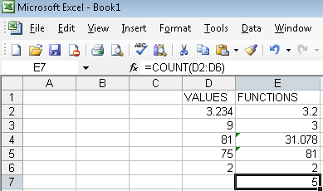

SUM ( )
=Sum(numX:numY)

- The sum ( ) function calculates the sum of entries in specified range. In our present example we have a range D2 to D6 for which we want to add up the numbers.

- Place the cursor where you want the function result to appear and choose function from the insert menu.
- Choose math & trig from the function category and sum from the function name. Click once on the OK button.
- Either type the range or point to the cells, which contains the numbers, which you want to add up. You may specify to discontinuous ranges using the second field.
- Click once the ok button.

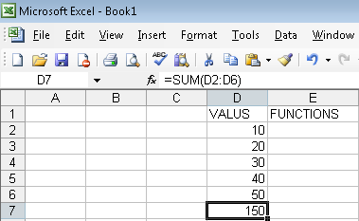

IF( )
=If(test_condition,”true_statement”,”false_statement”)

- The if () function is one of the most useful and powerful functions available in Ms excel. Through this function you can conduct conditional tests on values and formulas and execute some operation based upon the result of the text.
- The outcome of the test determines the value returned by the IF function. If the specified criteria or condition is satisfied if returns the value T otherwise F. you can specify two different actions to be performed, one for the true outcome, and the second one is false outcome. Suppose for example you have a value 150 in the cell address of D7.
- Place the cursor where you want the function result.
- Choose logical from the function category and if from the function name.
- Type the criteria that you want evaluated that is D7 > 100
- Specify the operation to be done if the criteria are satisfied.
We type the following formula: =If(D7>100,”Greater Than 100”,”Less Than100”)
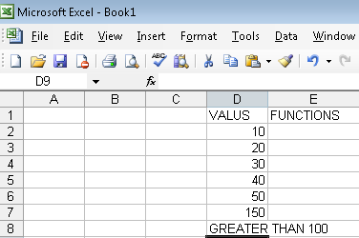

SUMIF ( )
=Sumif(range,”criteria”,”sum_range”)

The sum if () function is a combination of SUM and IF functions. Through this function you can add up a series of numbers from a specified range, provided t satisfy the given criteria.
Suppose you have a range of cells containing numbers and you want to add up only those numbers which qualify based upon a specified by you, then SUM IF is the function to use.

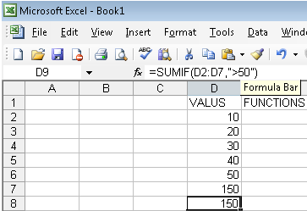

- Place the cursor where you want the function result to appear and choose function from the insert menu.
- Choose math trig from the function category and sum if from the function name. Click once the ok button to continue.
- Type or specify the range which you want evaluated based upon the criteria specified that is D2:D7.
- Specify the criteria or an expression which defines which number would be added up that is >50. You may note that the expression >50 excludes 50.
- Specify the range of cells from which you want the selected cells to be added that is D2:D7. In our example the range and sum-range happen to be same, though in some other cases they need not be.
- Click once the OK button.
- Since there are two numbers in the range, which are greater than 50(150) the sum of these comes to 150, which displayed in the cell where you had initially placed the cursor.

ABS ()
=ABS(range)

The ABS () function is used to get the absolute value of a number. The absolute value of a number means the number without plus or minus sign. For example we have a number –28 in the cell c6 for which we want to get the absolute value. To do this follows the steps below:
- Place the cursor where you want the function result to appear and choose function from the insert menu.
- Choose math & trig from the function category and ABS from the function name. Click once the ok button to continue.
- Type the cell address containing the number for which you want to calculate absolute value.
- Click once on the ok button.
- It will display the result +28.

ROMAN ( )
=Roman(range)

The roman () function is used to convert an Arabic in to roman digits. In cell D3 we have the value of 9, which we want to convert in to roman digits.
- Place the cursor correctly to get the result.
- Choose math & trig from the function category and roman from the function name.
- Click once the OK button to continue.
- Type or specify the cell address in which the number to be converted is there.
- Click the ok button.
- The result will come like this IX.

UPPER ( )
=Upper(range)

The upper ( ) function is used to convert lower case text entry in to upper case, that is capital letters.
- Place the cursor in correct position where you want to get the result.
- Choose the upper option form function category.
- Type or specify the cell address in which the text to be converted is there.
- Click the ok button.
- The text is changed in to capital letter.

LOWER ( )
=Lower(range)

The lower ( ) function is used to convert an upper case text in to lower case, that is small letter. To do this,
- Place the cursor position correctly where you want to get the result.
- Choose the lower ( ) function in function category. Type the text in desired place.
- It will convert the text in to small letter.

CELL ( )
=Cell(“info-type”,reference)

The cell ( ) function returns information about the formatting, location, or contents of the upper left cell in a reference. This is the fairly useful command and gives you all kinds of information about a cell or about the current file.

INFO TYPE | RETURNS
“ADDRESS” | Reference of the first cell in reference as text.
“COL” | Column number of the cell in reference.
“ROW” | Row number of the cell in reference
“FILE NAME” | File name of the file that contains reference as text. Returns empty test if the worksheet that contains reference, has not yet been saved.
“WIDTH” | Column width of the cell rounded off to an integer. Each unit of column width is equal to the width of one character in the default font size.

- Place the cursor where you want the function result to appear and choose function from the insert menu.
- Choose information from the function category and cell from the function name.
- Click the ok button.
- The results would be displayed in the cell where you had initially placed the cursor.
- Before you select the filename info type you must save the file.

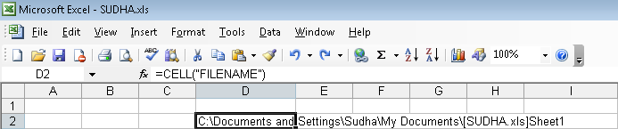

TODAY ()
=Today()

The today () function is one of the few functions that do not require any user argument. It simply returns the current date. This is done by the following commands.
- Place the cursor in position.
- Choose date and time from the function category and today from the function name. Click once the ok button.
- Since this function takes no arguments simply click once on the ok button.
The result would be displayed in the cell where you had initially placed the cursor.
=Now()

NOW ( )

The now( ) function is another of those few functions which does not require any user argument. It simply returns the current date & time.
- Place the cursor in correct position. Choose date & time from the function category and now from the function name. Click the ok button.
- Since this function takes no arguments, simply click ok button.
- The result would be displayed.
- SOME SHORT CUTS KEYS

All cells left of current cell | SHIFT + left arrow
All cells right of current cell | SHIFT + right arrow
Entire column | CTRL + Spacebar
Entire row | SHIFT + Spacebar
Entire worksheet | CTRL + A

Apply AutoSum | ALT +=
Current date | CTRL +=
Current time | CTRL +=
Spelling | F7
Help | F1
Macros | ALT + F8

Edit active cell | F2
Format as currency with 2 decimal places | SHIFT + CTRL + $
Format as percent with no decimal places | SHIFT + CTRL + %
Format cells dialog box | CTRL + 1

One cell up | Up arrow
One cell down | Down arrow
One cell right | Tab
One cell left | SHIFT + Tab
Top of worksheet  (cell A1) | CTRL + Home
End of worksheet  (last cell with data) | CTRL + End
End of row | Home
End of column | CTRL + left arrow
Move to next worksheet | CTRL + Page Down

